Contents

Contents 1
PDF Camera Data Model 2
Data elements of the PDF Camera 3
Definitions of the Data elements 4
INPUT MEMORY BUFFER: original document file (PDF syntax) 4
OUTPUT MEMORY BUFFER : original document file (PDF syntax) 4
DECOMPRESSION MEMORY BUFFER : for decompressed strings and cleaning / auto-corrections. 4
static context buffers ( pdf_buffer_static_context_t ) 5
roadmap context buffers ( pdf_roadmap_buffer_context_t ) 5
context buffers ( pdf_buffer_context_t ) 5
camera context ( pdf_context_t ) 6
Data elements of the PDF Camera ( DETAIL ) :- 6
static context buffers ( pdf_buffer_static_context_t ) 6
roadmap context buffers ( pdf_roadmap_buffer_context_t ) 6
context buffers ( pdf_buffer_context_t ) 7
camera context ( pdf_context_t ) 7
tokenisation context ( pdf_context_tokenisation_t ) 8
semantic context ( pdf_context_semantic_t ) 9
cleaning context ( pdf_context_cleaning_t ) 10
encryption context ( pdf_context_encrypt_t ) 10
Pdf camera main process loop (key elements) 11
Architectural Principles Of The PDF Camera 12
[ file level diagrammatic file type data flow view for the PDF Camera ] 14
PDF Document Object Model and Data Flow Diagrams 15
Software Interface 16
PDF Camera Dataflow - PREFILTER CYCLE 0 - INITIALISATION Dia(gram) 18
PDF Camera Dataflow - PREFILTER CYCLE 0 - ROADMAP INITIALISATION Dia(gram) 19
PDF Camera Dataflow - PREFILTER CYCLE 0 - ROADMAP MAIN PRCOCESS LOOP Dia(gram) 20

PDF Camera Data Model

INPUT MEMORY BUFFER
OUTPUT MEMORY BUFFER

DECOMPRESSION
MEMORY BUFFER
Contains PDF syntax before each process cycle.
Contains PDF syntax after each process cycle.
Reset before each process cycle. Grows during a process cycle.
static context buffers
roadmap context buffers
context buffers
camera context
Initialise the first time the camera is called
Initialise when the ROADMAP camera is called on the PREFILTER cycle 0
Initialise in the camera PREFILTER cycle 0.
Reset in other camera cycles 1/2/3.

In all camera cycles 0/1/2/3 :-
- clear all data,
- connect pointers to
context buffers.
- initialise PDF names
and graphic commands.

Data elements of the PDF Camera

- INPUT MEMORY BUFFER: original document file (PDF syntax)

- OUTPUT MEMORY BUFFER : original document file (PDF syntax)

- DECOMPRESSION MEMORY BUFFER : for decompressed strings and cleaning / auto-corrections.

- static context buffers pdf_buffer_static_context_t

- roadmap context buffers pdf_roadmap_buffer_context_t

- context buffers pdf_buffer_context_t

  - toolset context pdf_context_toolset_t
  - toolset statistics context pdf_context_statistics_t

- camera context pdf_context_t

  - tokenisation context pdf_context_tokenisation_t
  - semantic context pdf_context_semantic_t
  - cleaning context pdf_context_cleaning_t
  - encryption context pdf_context_encrypt_t
  - toolset context pointer pdf_context_toolset_t *
  - transforming context pdf_context_transforming_t

Definitions of the Data elements

INPUT MEMORY BUFFER: original document file (PDF syntax)

The input memory buffer is loaded with PDF document syntax by the Glasswall Software Framework before processing is initiated.

At the start of process cycles one (CLEANING) and three (VALIDATE) the input memory buffer is emptied.
Note the output buffer from a previous process cycle (ie now loaded with PDF syntax) becomes the new input buffer for process cycles one, two(POST-FILTER) and three.

The input memory buffer is the output buffer from PDF process cycle three (VALIDATE).

OUTPUT MEMORY BUFFER : original document file (PDF syntax)

The output memory buffer is loaded with PDF document syntax at the end of PDF process cycles zero (PRE-FILTER) and two (POST-FILTER)

The output buffer at the end of the mentioned process cycles contains PDF syntax which is correct in as far as Glasswall cleaning and validation has been applied in the current and previous process cycles.

The output memory buffer is the input buffer to PDF process cycle three (VALIDATE).

DECOMPRESSION MEMORY BUFFER : for decompressed strings and cleaning / auto-corrections.

The decompression memory buffer is used by the PDF decompression functions , cleaning mechanisms and the PDF auto-corrections system.

The decompression memory buffer is emptied at the start of each PDF process cycle.

The decompression memory buffer grows during each PDF process cycle.

A snapshot of the decompression memory buffer is taken before processing decompression for content streams.
The snapshot of the decompression memory buffer is applied to restore the decompression memory buffer after processing an individual or an array of content streams.

The snapshot restore mechanism is an optimisation which is particularly effective at reducing the memory requirement for processing larger (ie > 5MB) PDF files

static context buffers ( pdf_buffer_static_context_t )

The static context buffers context encapsulates fast access data lookup for various flags and other settings which may be indexed by the various software enumerations which identify PDF dictionary types and keys.
Fast lookup data fields include the string descriptions of dictionary types, PDF content management settings and the PDF normalisation configuration.
Note that the versioning of PDF keys and dictionaries is part of the PDF normalisation configuration.

The static context buffers are initialised from internal static tables the first time the PDF camera is called.

Some of the static context buffers are indexed using either a single index which may be a PDF Dictionary enumeration or a PDF Name enumeration.
Other static context buffers require a PDF Dictionary and PDF Name enumeration pair to access the fast look up value.

The use of the static context buffers is currently from PDF dictionary content management which is achieved through various cleaning and content management PDF token tree-walks. The PDF toolset provides several layers of “C” style classes which access the static context buffers via helper software functions.

roadmap context buffers ( pdf_roadmap_buffer_context_t )

The roadmap context buffers context contains a minimal set of global buffers which are required for creating a roadmap of the PDF document. A PDF document roadmap processes a PDF document into PDF tokens, which are then discarded, in order to create a roadmap statistical record for a document.

The roadmap statistical record provides an input to the resource allocation functions which will allocate an optimal set of context buffers to minimise the use of memory before for full tokenisation of document content.

The roadmap context buffers are initialised in process cycle 0(PREFILTER) by the PDF Roadmap sub-camera.

context buffers ( pdf_buffer_context_t )

The context buffers context contains a complete set of global buffers which are required in order to create a tokenised representation of a PDF document. The PDF document roadmap record configures the size of the context buffers which are allocated to sizes which are optimised for the current process PDF document file. This also considers the requirement for additional PDF syntax which may be inserted into a PDF file for transforming purposes such as adding a PDF watermark.

The context buffers are initialised in process cycle 0(PREFILTER) by PDF camera initialisation which is called after processing the PDF roadmap camera and before tokenising PDF document content on the pre-filter cycle.

camera context ( pdf_context_t )

The PDF camera context is a context which is passed throughout the PDF camera software function in order to allow PDF Camera helper functions to access any of the data elements provided by the PDF Camera.

The PDF Camera context is cleared at the start of each of the process cycles ( ie cycle 0(PREFILTER) 1(CLEANING) 2(POSTFILTER) 3(VALIDATE) ) and then various data elements hooked into the PDF Camera context. Generally, these will be the global buffers from the buffers context.

The PDF Camera context is also used by the PDF Camera roadmap sub-camera which clears the PDF Camera context in cycle 0(PREFILTER) .
In this case then the roadmap context buffers are hooked into the PDF Camera context used by the roadmap sub-camera which is a separate PDF camera content independent of the main PDF Camera context.

Data elements of the PDF Camera ( DETAIL ) :-

static context buffers ( pdf_buffer_static_context_t )

  - dictionary management policy [dictionary] (disallow, allow, remove)
  - allowed dictionary types [name] (dictionary)
  - allowed dictionary key types [name] (dictionary)
  - allowed dictionary sub types [dictionary] [name] (dictionary)
  - allowed dictionary key sub types [dictionary] [name] (name)
  - allowed dictionary keys [dictionary] (true/false)
  - allowed dictionary keys [dictionary] [name] (true/false)
  - supported dictionary type [name] (dictionary)
  - supported dictionary sub type [dictionary] [name] (dictionary)
  - supported dictionary characteristics [dictionary] (characteristics)
  - dictionary type strings [dictionary] (char *)
  - dictionary min. version (NORMALISE) [dictionary] (INT_16)
  - dictionary key config. (NORMALISE) [dictionary] [name] (mandatory, optional, unspec.)
  - dictionary key min. version (NORMALISE) [dictionary] [name] (INT_16)
  - dictionary key manage policy (NORMALISE) [dictionary] [name] (disallow, allow, remove)
  - dictionary virtual [dictionary] (true/false)
  - dictionary non standard [dictionary] (true/false)

roadmap context buffers ( pdf_roadmap_buffer_context_t )

  - roadmap section data pdfRoadmapSectionDataBuffer_t
  - names allowed for type and subtype [unit8_t] (true/false)
  - names hash table (ie DATABASE) [stringHashTable_t]
  - names found in file flags [unit8_t] (true/false)
  - names database pdfNamesDB_t
  - token array MP[pdfBasicObjectToken_t]
  - sections post process requests queue [pdfPostProcessRequest_t] (size = 100)
  - pointer to the context buffers pdf_buffer_context_t *

context buffers ( pdf_buffer_context_t )

  - roadmap record pdfSectionData_t
  - section data buffers pdfSectionDataBuffer_t
  - objects cross reference table DB [crossRefStruct_t]
  - objects data offsets found DB [dataFoundStruct_t]
  - objects order DB [unit32_t]
  - objects order (normalised) DB [unit32_t]
  - objects regeneration flags DB [unit8_t]
  - objects type/subtype found DB [pdfFileObjectContext_t]
  - names allowed for type and subtype [unit8_t] (true/false)
  - names hash table [stringHashTable_t]
  - names found in file flags [unit8_t] (true/false)
  - inflated streams IPS array [inPlaceString]
  - objects array MP[pdfIndirectObjectTokenList_t]
  - object handle dereference counters DB [unit32_t]
  - object reference descriptors DB [pdfObjectReferenceToken_t]
  - object reference linked lists DB [pdfBasicObjectTokenPtr]
  - post process requests queue DB [pdfPostProcessRequest_t]
  - token array MP[pdfBasicObjectToken_t]
  - token array for content stream tokens MP[pdfBasicObjectToken_t]
  - stream token lists [inPlaceTokenList_t]
  - font file stream object references [pdfBasicObjectTokenPtr]
  - page objects visited by semantics DB [unit32_t]
  - toolset tree node ID stack [unit16_t]
  - toolset tree node context stack [pdfBasicObjectTokenPtr]
  - toolset Tree node dictionary type stack [pdfBasicObjectTokenPtr]
  - toolset Tree node dictionary type list [pdf_toolset_linked_list_t]
  - common Area for array allocations MP[uint8_t]
  - camera parameter block copy pdfParamBlk_t
  - toolset context pdf_context_toolset_t
  - toolset statistics context pdf_context_statistics_t

KEY DB = Dynamic Buffer MP = Memory Pool

NB: Dynamic buffers are allocated from the common area memory poo

camera context ( pdf_context_t )

  - process file information pdfProcessFileInfo_t
  - process state pdfProcessState_t
  - process state log pdfProcessStateLog_t
  - process cleaning flags eGWCleaningFlags
  - trace flags eGWTraceFlags
  - process cycle number (0..3) uint8_t
  - recursion level uint32_t
  - content management applied flag eBoolean (true/false)
  - extract text process request flag eBoolean (true/false)
  - input/output/inflate memory buffers memoryBuffer *
  - original document version detected uint32_t
  - object number detected limits uint32_t
  - context buffers pdf_buffer_context_t *
  - static context buffers pdf_buffer_static_context_t *
  - section record pdfSectionData_t
  - section data buffers pdfSectionDataBuffer_t *
  - current section pdfSectionDataCurrent_t
  - objects cross reference table crossRefStruct_t *
  - objects data offsets found dataFoundStruct_t *
  - objects order unit32_t *
  - objects order (normalised) unit32_t *
  - objects regeneration flags unit8_t *
  - objects type/subtype found pdfFileObjectContext_t *
  - post process requests queue pdfPostProcessRequest_t *
  - statistics record pdfStatistics_t
  - various tokenisation registers
  - names allowed for type and subtype unit8_t * (true/false)
  - names database pdfNamesDB_t
  - names hash table stringHashTable_t *
  - names found in file unit16_t
  - stream graphics commands allowed [unit8_t] (true/false)
  - stream graphics commands in file [unit8_t] (true/false)
  - inflated streams IPS array inPlaceString *
  - sublevel tables for a single object
  - tokenisation context pdf_context_tokenisation_t
  - semantic context pdf_context_semantic_t
  - cleaning context pdf_context_cleaning_t
  - encryption context pdf_context_encrypt_t
  - toolset context pdf_context_toolset_t *
  - transforming context pdf_context_transforming_t

tokenisation context ( pdf_context_tokenisation_t )

  - stream in object collection flag eBoolean (true/false)
  - stream collection ID uint32_t (0..)
( zero for first stream in collection)
  - disable decryption of literal strings eBoolean (true/false)
  - force use of the crypt filter only eBoolean (true/false)
NB: any other filters will not be applied
  - is decompression from a post process eBoolean (true/false)
request
  - process original context without eBoolean (true/false)
inline checking or decompression
  - queue containing value tokens for [pdfBasicObjectToken_t]
attribute “/FontFile/2/3” for all
processed objects
  - size of queue attribute “/FontFile/2/3” uint32_t
  - track the offset from the start of the uint32_t[2]
file for the last cross reference table
  - index into the above table uint32_t
either 0 or 1.
  - document is “linearised” flag eBoolean (true/false)
  - COMMON AREA for array allocations MP[uint8_t]
  - COMMON AREA object number max. * uint32_t
  - COMMON AREA post process count max. * uint32_t
  - token array current pool buffer [pdfBasicObjectToken_t]
  - maximum limit for the token array uint32_t
  - token array memory pool MP[pdfBasicObjectToken_t]
  - queue of sections for post processing [pdfPostProcessSection_t]
  - objects array [pdfIndirectObjectTokenList_t]
  - objects array memory pool MP[pdfIndirectObjectTokenList_t]
  - create document roadmap flag eBoolean (true/false)
  - create document roadmap token flag eBoolean (true/false)
  - Pdf data found for the current section dataFoundStruct_t
  - Current Stream in-place-token list inPlaceTokenList_t

KEY DB = Dynamic Buffer MP = Memory Pool

NB: Dynamic buffers are allocated from the common area memory pool

semantic context ( pdf_context_semantic_t )
  - objects array MP[pdfIndirectObjectTokenList_t]
  - object handle dereference counters DB [unit32_t]

  - object reference descriptors DB [pdfObjectReferenceToken_t]
  - token array MP[pdfBasicObjectToken_t]
  - stream token lists [inPlaceTokenList_t]
  - object reference linked lists DB [pdfBasicObjectTokenPtr]
  - integrated trailer dictionary pdfTrailerDictionaryIntegrated_t

  - page objects visited by semantics DB [unit32_t]
  - pdf destination tree (semantics) pdfNameTree_t
  - pdf resources (semantics) pdfResource_t
  - pdf destination pages (semantics) pdfDestinationPages_t
  - pdf threads (semantics) pdfThreads_t
  - tree walk ID (semantics) uint32_t

  - content processing state pdfContentProcessingState_t

  - PDF Header token list pdfBasicObjectToken_t
  - Max. object number in objects array uint32_t
  - Max. object number in last cycle uint32_t
  - Size of the object references queue uint32_t
  - Number of tokens in the token array uint32_t
  - Root object number (ie Catalog) uint32_t
  - ‘IN USE’ cross ref. entries found uint32_t
  - ‘FREE’ cross ref. entries found uint32_t
  - cross ref. updates count uint32_t
  - byte offset of the last cross ref. table uint32_t
  - trailer dictionary in-place-token-list inPlaceTokenList_t
  - virtual object pdfIndirectObjectTokenList_t
  - object profile pdfObjectProfile_t
  - semantic processing state pdfProcessStateLogSemantic_t

  - pointer to the MAIN PDF context pdf_context_t *

  - semantic loop check counter long
  - semantic trace area char *
  - semantic post script stack psStack_t

  - test extracted size uint32_t
  - content stream extracted buffer memory buffer *

KEY DB = Dynamic Buffer MP = Memory Pool

NB: Dynamic buffers are allocated from the common area memory pool

cleaning context ( pdf_context_cleaning_t )

  - cleaning profile table ( type/subtype) pdfCleaningProfile_t [ 20 ]
  - cleaning profile bitmask ePdfContentManagementBitmask
  - cleaning profile detected bitmask ePdfContentManagementBitmask
  - cleaning profile applied bitmask ePdfContentManagementBitmask
  - document content policy bitmask ePdfContentPolicyBitmask
  - token cleaning control bitmask eGWCleaningControlFlags
  - token cleaning trailing in-place-string inPlaceString
  - token tree key back links allowed list ePdfName *
  - normalisation version uint16_t
  - normalisation version count uint8_t

encryption context ( pdf_context_encrypt_t )

  - document is encrypted flag eBoolean (true/false)
  - encryption is enabled eBoolean (true/false)
  - encryption control eControlEncrypt_t
  - encryption status eStatusEncrypt_t
  - encryption algorithm parameters pdfInflationAlgorithmParms_Crypt_t
  - encryption parameter ID one inPlaceString
  - encryption parameter ID two inPlaceString
  - encryption parameter ID one array uint8_t [32]
  - encryption parameter ID two array uint8_t [32]
  - encryption key buffer uint8_t [128]
  - encryption dictionary object number uint32_t

Pdf camera main process loop (key elements)

The PDF camera main process loop encapsulates functionality as follows :-

Pdf camera main process loop (key elements)
      - Open process
      - Initialise process
        - Static buffers
        - Dynamic buffers
        - Context
      - Syntactic processing to tokenise sections
        - Header
        - Body
          - Objects
          - Cross-reference tables
          - Trailers
          - Comments
          - Non-standard sections
      - Post syntactic processing
        - Tagging / manage content
        - PDF tool-set applications
          - ANALYSE (statistics)
      - Semantic processing to check file conformance and apply transformations
      - Post semantic processing
      - Assemble tokens to the PDF regeneration buffer
      - Close process

pdf camera context
- Static buffers
- Dynamic buffers
- Context
  - Process
  - Tokenisation
  - Compression
  - Cleaning
  - Encrypt
  - PDF Tool-set
  - Semantic

The PDF camera make use of STATIC (ie application life-cycle) and DYNAMIC (ie process file life cycle) software buffers and a process software context which has links into the STATIC /DYNAMIC buffers.

Note that common dynamic buffers are allocated as blocks of memory from the common area memory pool.

Architectural Principles Of The PDF Camera

The key to the PDF camera architecture is to understand the break-down of camera functionality into manageable areas (i.e SYNTAX_TOKENISATION / SEMANTICS / CLEANING / DECOMPRESSION / REGENERATION / REPORTING), and with four camera process cycles each with distinct functionality :-

- PRE-FILTER (0): correct file content and standardize

- CLEANING (1): apply CONTENT MANAGEMENT policies (ALLOW, REMOVE, DISALLOW)
and semantic cleaning

- POST-FILTER (2): correct file content and standardize after cycle (1)

- VALIDATE (3): apply VALIDATE/PROTECT policies

The above architecture has been shown to be highly effective with its use of multiple process cycles for a PDF camera as follows :-

- PDF camera cycle model (4 cycles) which activates distinct camera functionality according to the process cycle :-

  - CYCLE 0 – PRE-FILTER: application of a software “stencil” to include syntactic elements which may be linked together with a minimum of processing, involving only token walks and few calls to decompression functions, except when this is necessary to obtain syntactic objects for the required token tree walk. Any file type objects which are not within the token tree walk for the file type will be excluded from the file buffer. This cycle also makes any corrections to the contents of syntactic objects and regenerates a file memory buffer formatted with PDF syntax.

  - CYCLE 1 – CLEANING: apply CONTENT MANAGEMENT policies (ALLOW, REMOVE, DISALLOW) to file content for a the PDF camera.. Apply semantic corrections to file type tokens and syntactic content which is decompressed on demand by semantic processing in a camera.

  - CYCLE 2 – POST-FILTER: application of a software stencil for the PDF camera to include all file type objects which are found in the token tree walk starting at the root of a file type token tree walk. This cycle ensures that any un-wanted file-type content from the cleaning cycle is not included in the regenerated file buffer for the camera.

  - CYCLE 3 – PROTECT: apply PROTECT policies to file content. Ensures that syntactic content like font faces may be opened and are formed correctly. Perform the various semantic walks to analyze the document and ensure that it is formed correctly for the current camera file type.

The PDF camera is realized through multiple scans (i.e. process cycles ) with swapping of the output buffer of each stage to be the input buffer of the next stage in order to achieve modularization of camera functionality.

This approach of multiple scans of processed file content applies the software concept of a software pipe-line with a filter stage at each node.

The filter stage at each node on the software pipe encapsulates particular functionality which may not be easily applied simultaneously at all pipe-line nodes.

The file level diagrammatic file type data flow view for the PDF Camera software is shown on the next page :-
[ file level diagrammatic file type data flow view for the PDF Camera ]
INPUT FILE TYPE
( original file )

GLASSWALL INPUT MEMORY BUFFER
LOAD INPUT BUFFER FROM FILE
GLASSWALL CONTEXT BUFFERS

TOKENISE INTO A CAMERA CONTEXT
GLASSWALL INTERMEDIATE BUFFERS
GLASSWALL OUTPUT MEMORY BUFFER
APPLY TOKEN AUTO-CORRECTIONS

CREATE REGENERATED BUFFER FROM TOKENS

APPLY PRE-FILTER TO TOKENS

PRE-FILTER (CYCLE 0)
GLASSWALL INPUT MEMORY BUFFER
SWAP INPUT and OUTPUT BUFFERS

GLASSWALL CONTEXT BUFFERS

TOKENISE INTO A CAMERA CONTEXT
GLASSWALL INTERMEDIATE BUFFERS
GLASSWALL OUTPUT MEMORY BUFFER
APPLY TOKEN AUTO-CORRECTIONS

CREATE REGENERATED BUFFER FROM TOKENS

APPLY CONTENT MANAGEMENT TO TOKENS

CLEANING (CYCLE 1)
APPLY SEMANTIC CORRECTIONS TO TOKENS
MANAGEMENT TO TOKENS

GLASSWALL INPUT MEMORY BUFFER
SWAP INPUT and OUTPUT BUFFERS

GLASSWALL CONTEXT BUFFERS

TOKENISE INTO A CAMERA CONTEXT
POST-FILTER (CYCLE 2
)
GLASSWALL INTERMEDIATE BUFFERS
GLASSWALL OUTPUT MEMORY BUFFER
APPLY TOKEN AUTO-CORRECTIONS

CREATE REGENERATED BUFFER FROM TOKENS

APPLY POST-FILTER TO TOKENS

GLASSWALL INPUT MEMORY BUFFER
SWAP INPUT and OUTPUT BUFFERS

GLASSWALL CONTEXT BUFFERS

TOKENISE INTO A CAMERA CONTEXT
VALIDATE (CYCLE 3
)
GLASSWALL INTERMEDIATE BUFFERS
GLASSWALL OUTPUT MEMORY BUFFER
CREATE REGENERATED BUFFER FROM TOKENS

VALIDATE/PROTECT TOKEN CHECKING

WINDOWS APPLICATION
SAVE OUTPUT BUFFER TO FILE VIA GLASSWALL DLL

WINDOWS APPLICATION
OUTPUT FILE TYPE
( regenerated file)

WINDOWS APPLICATION
CONFIGURE AND ACTIVATE GLASSWALL DLL

PDF Document Object Model and Data Flow Diagrams

This following sub-sections provide diagrammatic views of the PDF camera Document Object Model and a software data flow perspective for each of the process cycles (0/1/2/3) for the PDF camera.

The diagrammatic views describe the flow of data from an original file type into memory buffers and then into data elements,which encapsulate software tokens, and the assembly of these data elements and software tokens into a regenerated output buffer in order to provide the core Glasswall functions of Analyse, Manage and Protect by the end of process cycle three (i.e. the VALIDATE process cycle).

The data elements for the PDF camera document object model are :-

- INPUT MEMORY BUFFER: original document file (PDF syntax)

- OUTPUT MEMORY BUFFER : original document file (PDF syntax)

- DECOMPRESSION MEMORY BUFFER : for decompressed strings and cleaning / auto-corrections.

- static context buffers pdf_buffer_static_context_t

- roadmap context buffers pdf_roadmap_buffer_context_t

- context buffers pdf_buffer_context_t

  - toolset context pdf_context_toolset_t
  - toolset statistics context pdf_context_statistics_t

- camera context pdf_context_t

  - tokenisation context pdf_context_tokenisation_t
  - semantic context pdf_context_semantic_t
  - cleaning context pdf_context_cleaning_t
  - encryption context pdf_context_encrypt_t
  - toolset context pointer pdf_context_toolset_t *
  - transforming context pdf_context_transforming_t

The diagrams in the following sections illustrate though top and mid levels software interfaces how the PDF camera initialises its data element in each of the four process cycles (0/1/2/3) and then how these data elements are created and used within each of the PDF camera process cycles.

Software Interface
Also known as the software function interface for the PDF camera document object model.

The section lists the top and mid level software interface to achieve PDF camera processing :-

A.1 GlassWALLProcessConfig Configure Glasswall processing
A.2 GlassWALLProcess Activate Glasswall processing

B.1 pdfCameraConfig PDF camera configuration.
Set the camera XML configuration and
decode context bit masks into XML records.

B.2 pdfCamera PDF camera processing entry point

B.2.1 pdfToolsetProcessInit Toolset initialisation
B.2.2 pdfCameraRoadmap Camera roadmap entry point
B.2.3 pdfInitialise Camera initialisation
B.2.4 pdfInitialiseCtxtStaticBuffers Static Context buffers initialisation
B.2.5 pdfOpenProcess Open camera processing
B.2.6 pdfParseDocumentSections Parse document sections (e.g. header,
object, cross ref. table, trailer ..)
B.2.7 pdfContextFinaliseSyntacticProcess Finalise syntactic processing
B.2.8 checkPdfFileStructure Check document file structure
B.2.9 pdfCheckCrossReferenceTableAndTrailer Validate cross reference tables
offsets against pdf object offsets.

B.2.10 pdfContextPostSyntacticProcess Post syntactic processing to process
any toolset applications: stencil
token tree content management;
syntactic and semantic cleaning; object references validation

B.2.11 pdfCameraCheckTokenArrayLinkageIntegrity Token array link integrity self
Check

B.2.12 processCleaningRequestApplyStencilFilterContentManagementToTrailer
Apply stencil content management to
the trailer dictionary in PREFILTER cycle

B.2.13 processCleaningRequestToRemoveDocumentEncryption
Remove document encryption on the
PREFILTER cycle (i.e. if required)

B.2.14 processCleaningRequestApplyStencilFilterContentManagementToTrailer
Apply stencil content management to
the trailer dictionary in POSTFILTER cycle

B.2.15 pdfValidateRootObjectTokenList Semantic validation of document tokens

B.2.16 pdfContextPostSemanticProcess Semantic validation post processing
steps through normalised objects and
forces checked and valid for tokens
which do not already have this status.

B.2.16 pdfProcessOutput Assemble tokens in the regeneration
buffer applying cleaning requests to
keep, remove and standardise
regenerated tokens.

B.2.17 pdfCloseProcess Close camera processing : resets
the copy of the camera parameter
block and the PDF names database.

PDF Camera Dataflow - PREFILTER CYCLE 0 - INITIALISATION Dia(gram)

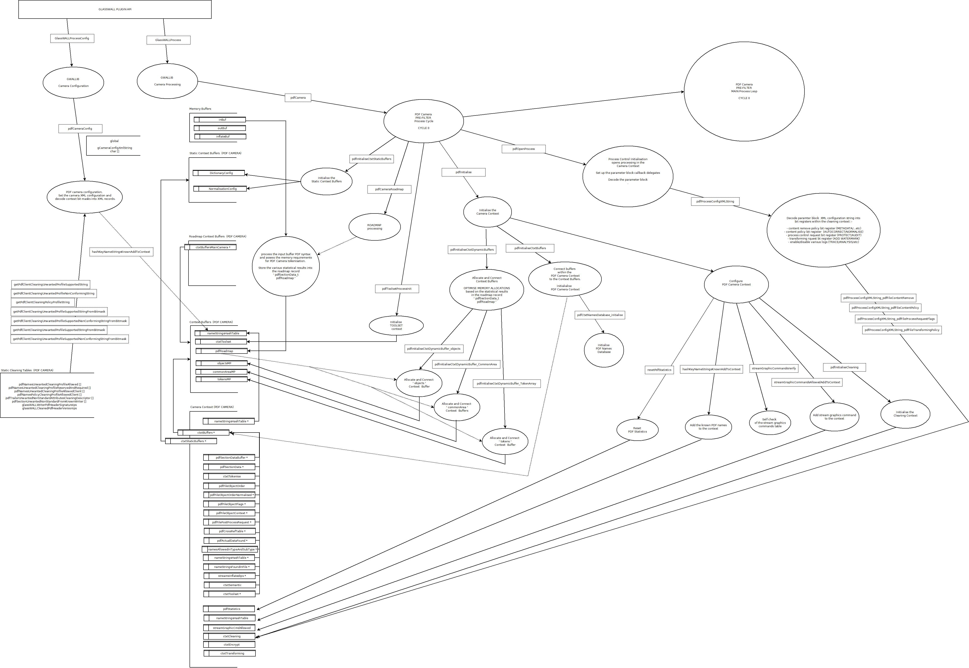

PDF Camera Dataflow - PREFILTER CYCLE 0 - ROADMAP INITIALISATION Dia(gram)

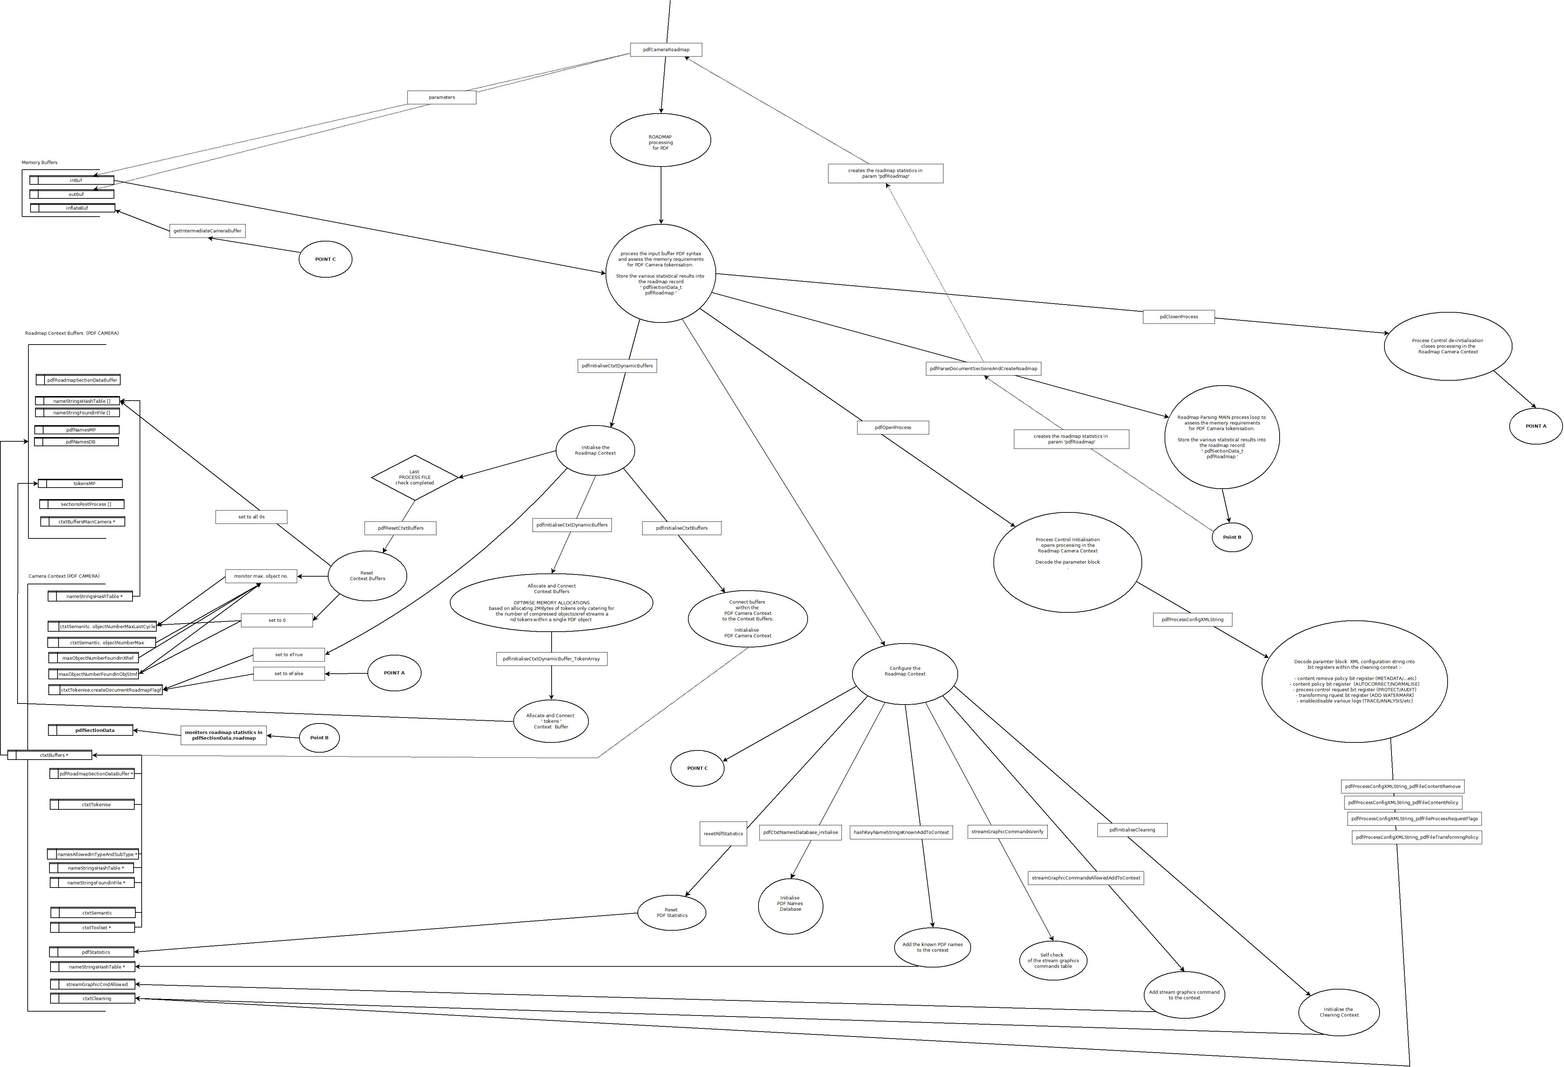

PDF Camera Dataflow - PREFILTER CYCLE 0 - ROADMAP MAIN PRCOCESS LOOP Dia(gram)

